**The Harvesters**

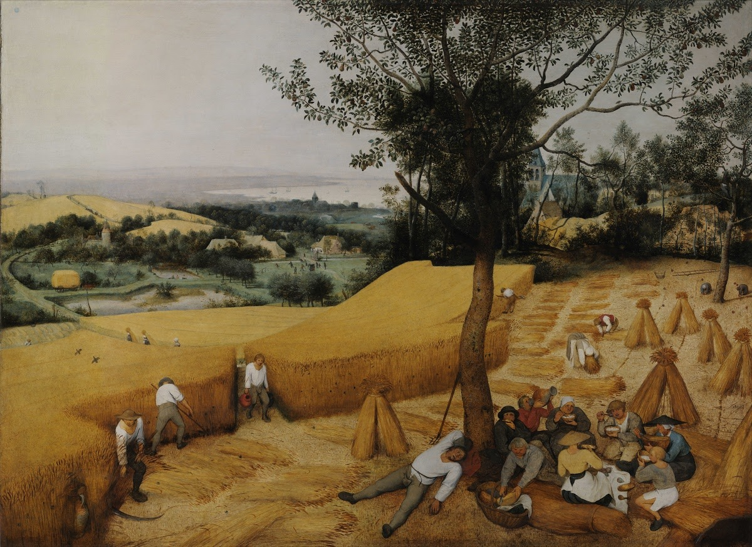

The Harvesters is an oil painting, painted on wood, of a field which in Netherlands by Dutch painter Pieter Bruegel the Elder, painted in 1565. It depicts the harvest time in Netherlands in late summer. The painting is one in a series of six works, five of which are still extant, that depict different times of the year.[1] Artist used materials which are oil paint colors nd tubes and a “wood”. The size of the painting has a height of 119 cm and a width of 162 cm and it has been at the Metropolitan Museum of Art in New York City, United States of America since 1919.[2]

The Harvesters (1565), it is an oil painting on wood showing a farming field in hot, late summer harvesting day with a tremendous view and colors. There are peasants which are working in white clothes with tool in their hands and there are peasants which are sitting under the tree, eating or sleeping. The painting shows a large number of activities representative of the 16th-century Belgian rural life. For example, on the far right a person is shaking apples from the tree. In the center left of the painting, a group of villagers can be seen participating in the blood sport of cock throwing.[3]

**Art Elements of The Harvesters**

In The Harvesters, the artist uses straight, curved and realistic lines. Many lines draw your eye throughout the work. The implied line made by the rows of harvested wheat, actual line form the unharvested wheat, grassy path, and trees direct your eye back and forth across the piece. The vertical lines of the tree and wheat structures draw your gaze upwards.[4]

In The Harvesters, the artist uses straight shapes to illustrate the view, wheat, grass etc.. He used shapes like he is copied the real view he saw. The shapes are so similar to real world. Especially, trees are very realistic. He used organic shapes all over the picture, so that is what makes that painting, artwork so realistic like it is a photo taken from a camera. In this way we can say that this artwork has an actual texture and pattern. It feels like real. You can feel the tempature and a warm wind if you look at the painting enough.

In this painting artist used shades of yellow, green and brown, maybe gray. Generally, in this painting colors are looking cold and faded. There are some color saturations to help attract attention on the foreground. Yellow and green background is different from yellow and green on foreground. In background, colors are more saturated and on foreground colors are more alive. If we look away in painting, we can see that green turns to gray.

In this painting, we can’t totally say artist made great and perfect use of space becaue of some villagers on foreground, but we can say that artis made good use of space. Through to vanishing point colors became gray. Artist also utilizes atmospheric perspective. The people closest to the foreground are in clear focus. The landscape behind them, particularly towards the lake does not have as much detail and fades into the sky.[5] He made balance between light and dark good and he made this painting like it is taken by a camera, as I said before. Thus, we can say that artist used implied motion in this painting.

**Principles of Design**

Lines don’t have variety that much in the painting. Mostly there is straight lines and some curved lines. We can say the same thing for colors. There is just 3 or 4 colors and their shades. When we look at it we can see that it is mainly yellow and green but if we talk about unity of lines and colors we can say that there is an evident unity. There are many straight lines all over the painting and we can see that some part of the painting is yellow and some part of it is green.

In this painting we can say that there is a balance between colors and lines because they are same in some parts as I said before. If we look at wheats there is a great balance between lines and colors and it looks so smooth. Also we can say that the focal point in this painting is where villagers sitting and eating together. Color and lines are more visible and sharp on this point but we can’t say that this is the main point of the painting because in this painting landscape dominates and those farmers are playing supplementary role. Bruegel painted the people in to play a supplementary role, as they help show how grand nature really is.[6]

The most striking part of the painting is wheats. There is a pattern which created with straight lines and this pattern has a rhythm which can make viewer look at it for minutes. The proportion is well defined in this painting, the trees fields and figures that are in foreground is bigger and more with detail than those in background. In addition, there is a depth in this painting thorugh vanishing point, in the sky where the colors became more colorless and gray so artist used lines and colors perfectly to create a great three-dimensional art.

**Context**

The Harvesters is an art of the Northern Renaissance. In 16th century, most of the artists were using religious theme in their paintings and Pieter Bruegel the Elder was one of the painters that abonded the religious themes in his paintings and focused on people (but he painted mainly religious themes before). Humanism puts humans central and make them focus no the values and humanism has an influence on realistic depictions of people and nature, their environments. We can see realism in Bruegel’s paintings.

As I said before, focal point of the painting is where peasents sitting together and eating. Painting’s lines and colors are sharper there. Also there was a church on the right side of the painting but then Bruegel painted a tree on it. Because of that we can say that he wanted us to focus on people, not religious things.

There are women and men working together as equal. We can see men working on the left side of the painting and women working on the right side of the painting. Also they are sitting together under the tree so there is no discrimination between genders, they are all working together.

Most of his paintings were detailed with peasants. He focused on showing their culture, their normal life with nature. In my opinion, in this painting there is no religious or feminism message, he just pictured normal peasants regular life, their culture, traditions by making them the main thing of the painting with lanscape, nature.

**Conclusion Remarks and Opinions**

In The Harvesters, artist uses art elements such as curved, vertical, horizontal and straight lines, similar shapes, similar patterns and some different shades of colors to create this painting. He used straight, vertical and horizontal lines to create sky, wheats and ground. Artist mainly used yellow, green and gray. He used yellow to illustrate field, used green to create trees and grasses and used grey to show us vanishing point and because of that the depth is perfect. Also in my opinion, he used cold colors to make viewer feel how hot the weather. Shortly, in this picture there is a perfect harmony with perspective, colors, line and depth.

# References

*Art Analysis.* December 19, 2013. http://artfinalanalysis.blogspot.com/2013/12/the-harvesters.html (accessed April 2020, 21).

*Critique of The Harvesters by Pieter Bruegel the Elder.* n.d. https://www.megaessays.com/viewpaper/8206.html (accessed April 21, 2020).

*The Harvesters (painting).* April 6, 2020. https://en.wikipedia.org/wiki/The_Harvesters_(painting) (accessed April 21, 2020).

1. Information about painting taken from: https://en.wikipedia.org/wiki/The_Harvesters_(painting)
2. Size information is taken from: https://en.wikipedia.org/wiki/The_Harvesters_(painting)
3. Painting’s information taken from: https://en.wikipedia.org/wiki/The_Harvesters_(painting)
4. Line information taken from: http://artfinalanalysis.blogspot.com/2013/12/the-harvesters.html
5. Perspective information taken from: http://artfinalanalysis.blogspot.com/2013/12/the-harvesters.html
6. Information is taken from: https://www.megaessays.com/viewpaper/8206.html